**Preparing an ODK Form for InterVA App**

This guidance document contains steps for creating and ODK Form that can send and receive relevant data to and from InterVA App. This form preparation requires Microsoft Excel and some prior knowledge of Visual Basic for Excel.

**Showing Developers Tab in Excel**

If you have not previously worked with Visual Basic in Microsoft Excel, you will need to show Developers tab by following the steps below:

* Right click anywhere on the ribbon, and then click **Customize the Ribbon.** 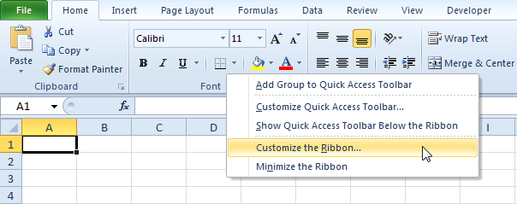
* Under **Customize the Ribbon,** on the right side of the dialog box, select **Main tabs** (if necessary).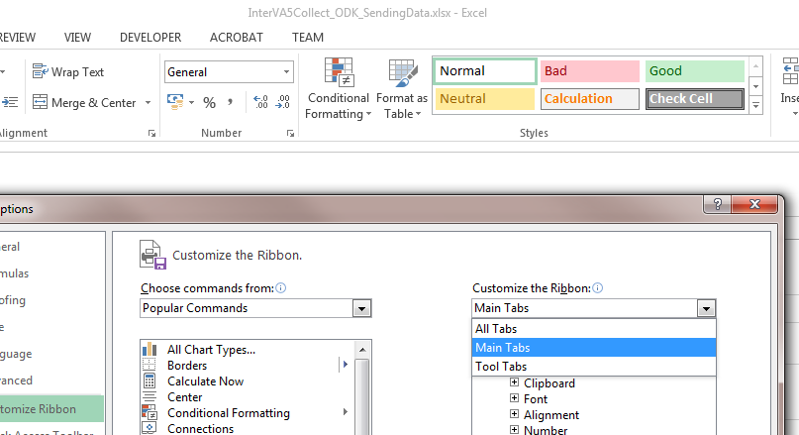
* Check the **Developer** check box. 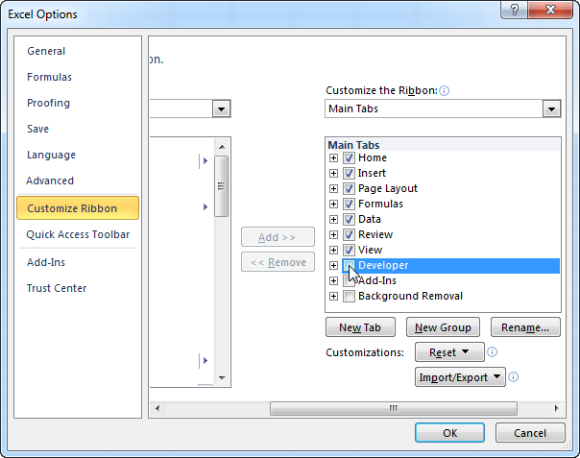
* Click **OK**
* You can find the **Developer** tab next to **View** tab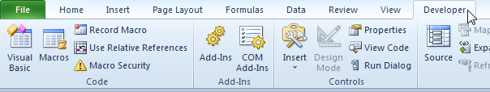

**Using Visual Basic Modules in Excel**

We have provided a Visual Basic code that speeds up the form preparation. Please ensure that you follow the steps below to add each module to you excel sheet.

Before we start, you will have to save your excel sheet in **.xlsm** format. This will enable us to run our Visual Basic Macros. Once we are done we will be copying text into the **.xlsx** sheet so please keep this for now.

To save **.xlsx** sheet into **.xlsm** format follow these steps:

* Go to **File->Save As**
* Select the folder and file name.
* From the **Save as type** drop down, select **Excel Macro-Enabled Workbook (*.xlsm)**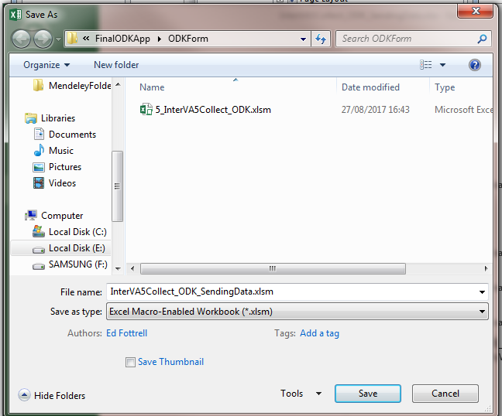
* Click **Save**

**Using Macros to Generate Form Entries**

Now we have an **.xlsm** form, where we want to run the macros and generate additional form entries required by InterVA app.

**Creating Additional Entries**

To add additional entries required by InterVA app follow the steps below:

* Open **\*.xlsm** form
* At the end of the form add the following three additional rows

|  |  |  |
| --- | --- | --- |
| **type** | **Name** | **label** |
| note | allAnswers | Answers |
| note | allQuesCodes | Question Codes |
| note | allQuesDesc | Question Descriptions |

* After adding these you form will look like this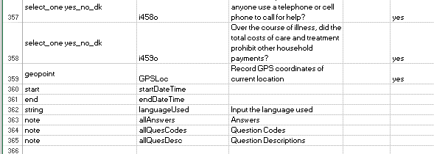

**Adding Visual Basic Modules to the .xlsm form**

We have provided three Visual Basic Modules required to generate the calculation entries for the additional rows we added. These are contained in **1_concateAnswersVBA.txt**, **2_concateQuestionsCodesVBA.txt** and **3_concateQuestionsDescriptionVBA.txt** files. To add these to your **.xlsm** form follow the steps below.

* Open your **.xlsm** file
* Go to **Developer** tab and select **Visual Basic**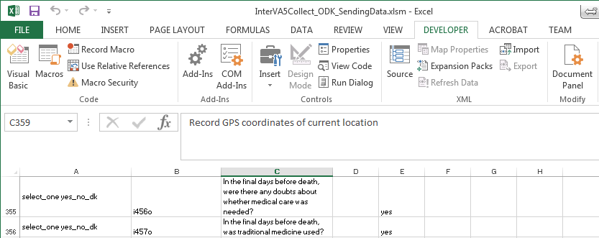
* You will be presented with Visual Basic window. Right click on **Microsoft Excel Objects** and select **Insert->Module**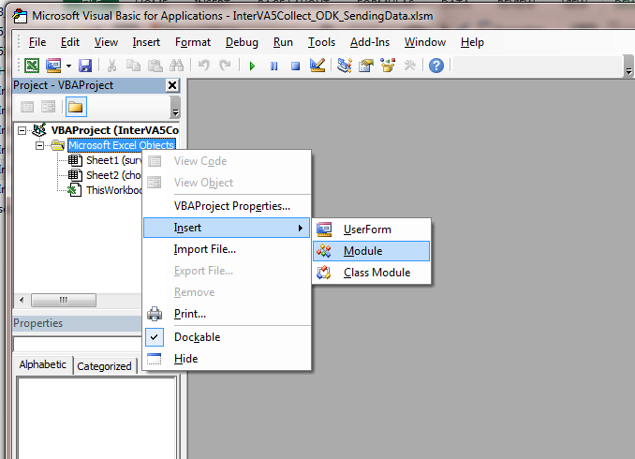
* This will add a module and open a place to write your VBA code. Copy and paste the VBA code from **1_concateAnswersVBA.txt** in the module.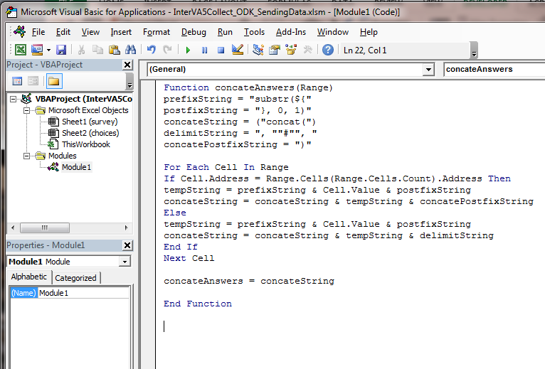
* Repeat the process by adding additional modules and pasting the code from **2_concateQuestionsCodesVBA.txt** and **3_concateQuestionsDescriptionVBA.txt** files.
* Once done click on **Save** icon and return to your excel sheet window

**Using Visual Basic Modules to Generate Calculation columns**

We now have everything setup and only need to run the VBA codes to generate the calculation columns for each of the three additional entries that we added to the sheet.

To add calculation column for **allAnswers** follow the steps below

* Click on **calculation** column (col F) in from of **allAnswers**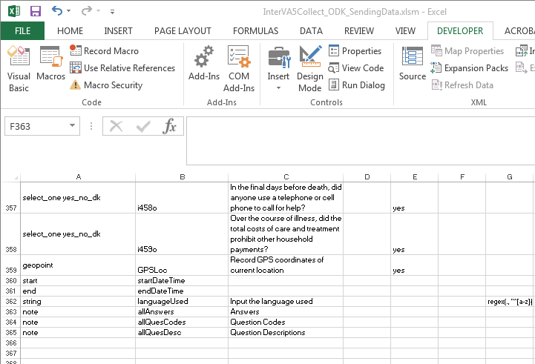
* In the function (**fx**) space start type “**=concatenateAnswers**” and select the **concatenateAnswers** function that comes up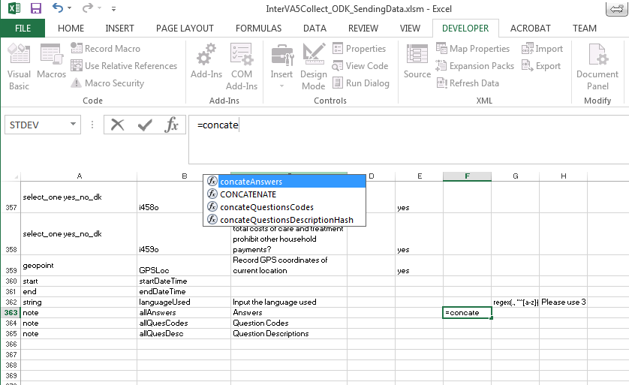
* Once selected you will need to provide input arguments. From the **name** column click on the first InterVA question (in this case **i004**). While holding **shift** key scroll to the bottom and click on the last question (in this case **i459o**) 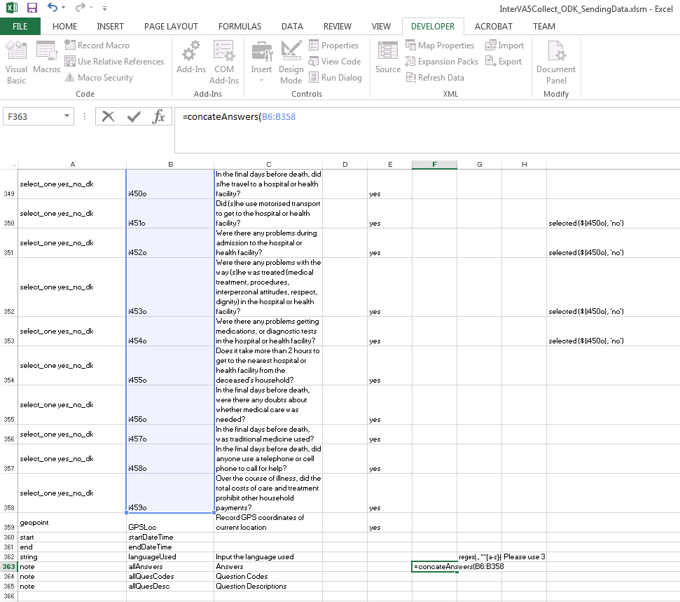
* Hit enter and you are done with **allAnswers**
* Repeat the process for **allQuesCodes** by using “**=concatenateQuestionsCodes**”
* Repeat the process for **allQuesDesc** by using “**=concatenateQuestionsDescription**” this time selecting the **label** column for questions
* You would have now completed the column generation part

**Preparing .xlsx form for XML form generation**

You now require to copy the additional row with generated columns to the original **.xlsx** sheet that you started with. To do this, follow the steps below:

* Open the **.xlsx** form and navigate to the bottom
* In the **.xlsm** form copy the three rows that we have added
* Paste them at the end of .**xlsx** form. You will see missing entries where we used the Macros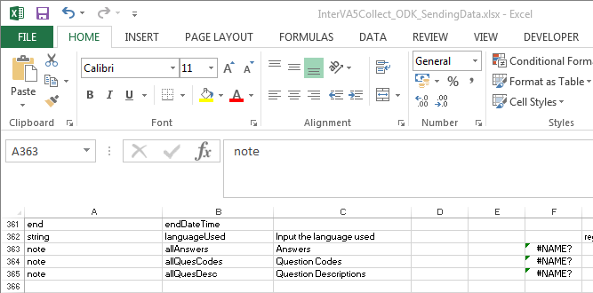
* To get the values instead of Macro entries click the paste option or alternatively hit **Ctrl**
* Select **Values** or press **V** while holding **Ctrl** (Ctrl + V)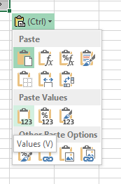
* This will convert the Macros into values. Save the form as we are now ready to generate .**xml** form for use with ODK Collect App

**Generating XML Form from XLSX**

Follow the steps below to convert the **.xlsx** form to **.xml** that will be used in our ODK Collect App.

* Open a web browser and navigate to : <http://opendatakit.org/xiframe/>
* Click **Browse** and select your **.xlsx** form that you wish to convert
* Click **Submit**
* Click **Download** and saved the form in the same folder as the **.xlsx** file

**Adding Details Related to InterVA App in XML Form**

We now have an **.xml** form that should work with ODK Collect App. We only need to do a few modifications to the file, so that it can enable the data to be sent to InterVA App.

Follow the steps below to do these necessary modification. In this tutorial we assume that the **.xml** file name is **InterVA5Collect_ODK_SendingData.xml** please replace the highlighted text with the name of your own form (if different).

* Open the **.xml** file and copy the following line inside the <instance>

**<InterVAResults/>**

* Add the following line inside the <model>

**<bind nodeset="/InterVA5Collect_ODK_SendingData/InterVAResults" type="string"/>**

* Delete the following lines from the end of the **.xml** form

**<input ref="/InterVA5Collect_ODK_SendingData/allAnswers">**

**<label>Answers</label>**

**</input>**

**<input ref="/InterVA5Collect_ODK_SendingData/allQuesCodes">**

**<label>Question Codes</label>**

**</input>**

**<input ref="/InterVA5Collect_ODK_SendingData/allQuesDesc">**

**<label>Question Descriptions</label>**

**</input>**

* Add the following lines at the end of <h:body>

**<input appearance="ex:com.example.android.SENDDATA(allAnswers= /InterVA5Collect_ODK_SendingData/allAnswers, allQuesCodes= /InterVA5Collect_ODK_SendingData/allQuesCodes, allQuesDesc= /InterVA5Collect_ODK_SendingData/allQuesDesc, GPSLoc= /InterVA5Collect_ODK_SendingData/GPSLoc, VAID= /InterVA5Collect_ODK_SendingData/id, startDateTime= /InterVA5Collect_ODK_SendingData/startDateTime, endDateTime= /InterVA5Collect_ODK_SendingData/endDateTime, languageUsed= /InterVA5Collect_ODK_SendingData/languageUsed)" ref = "/InterVA5Collect_ODK_SendingData/InterVAResults">**

**<label>** **Click launch to send collected data using external SMS app. Make sure to first save and finalise this form from next page. This is required to get End Date and Time.</label>**

**</input>**

* Hit **Save** and close the file
* You can now transfer the xml form to your phone and use it with the InterVA App